**Use alternative in smart forms**

For the initial steps to create a smart form, please refer the previous demos.

1. Create a smart form.

2) Double click on Form Interface and declare the following 2 parameters.

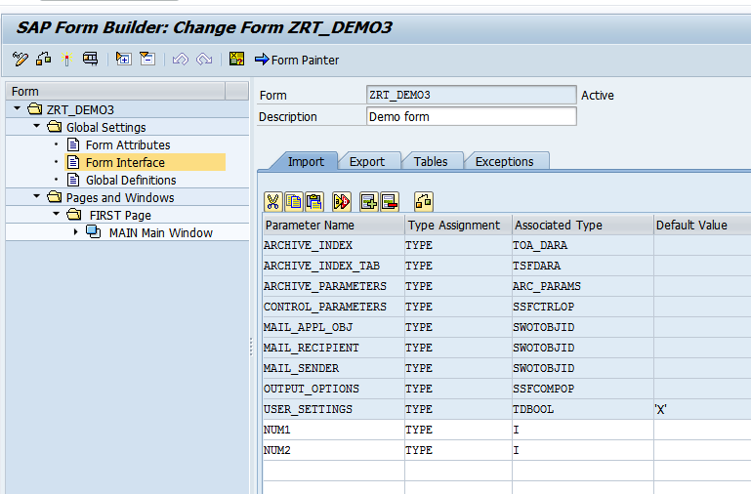

3) Right click on MainWindow .Create-FlowLogic->Alternative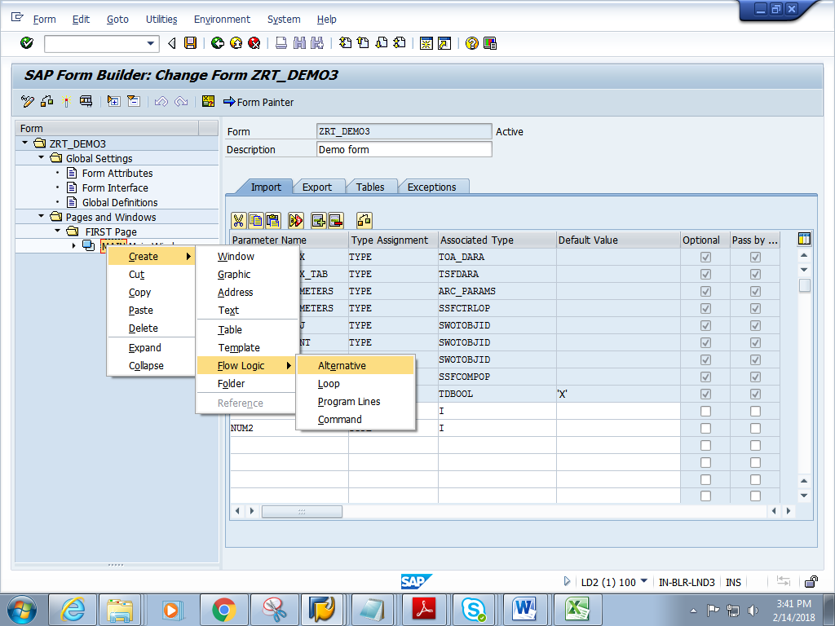

4) Double click on CONDITION .In the General attributes tab, add the below condition.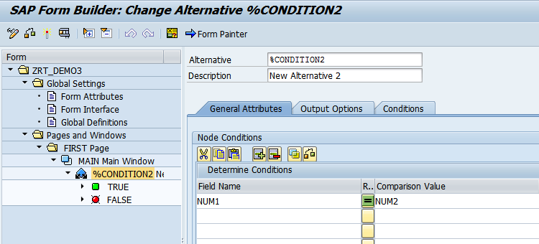

5) Right click on TRUE. Create-> TEXT.

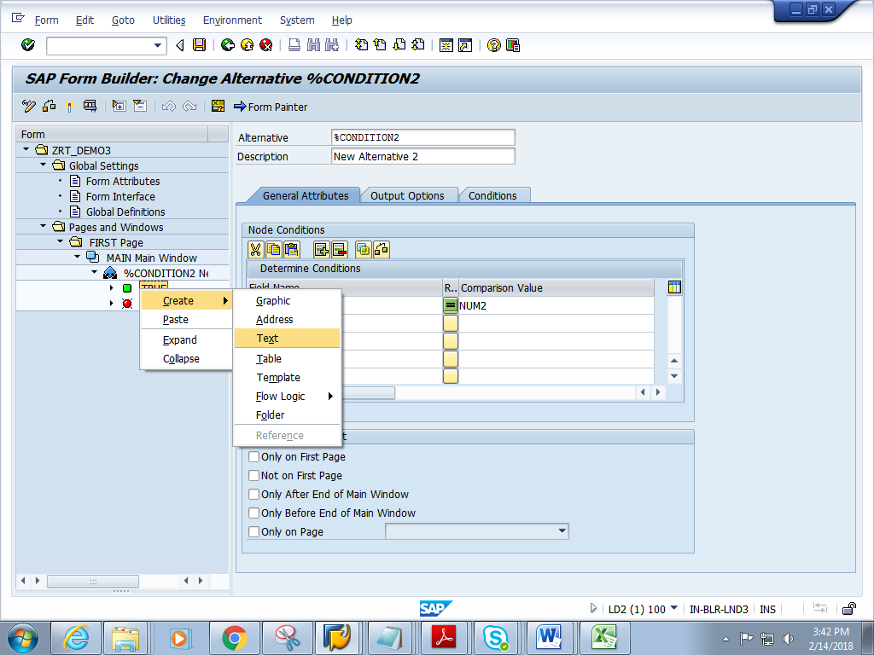

7) Add the below text.

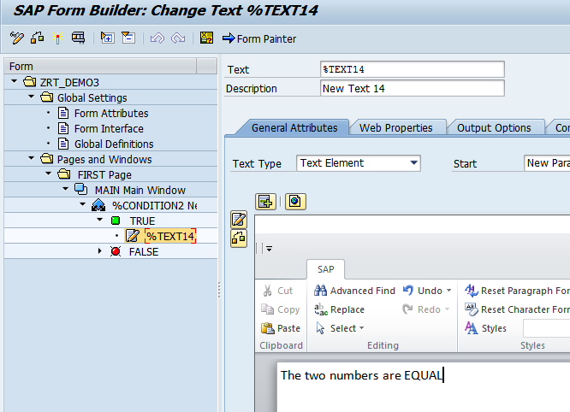

8) Similarly right click on FALSE and create text2.

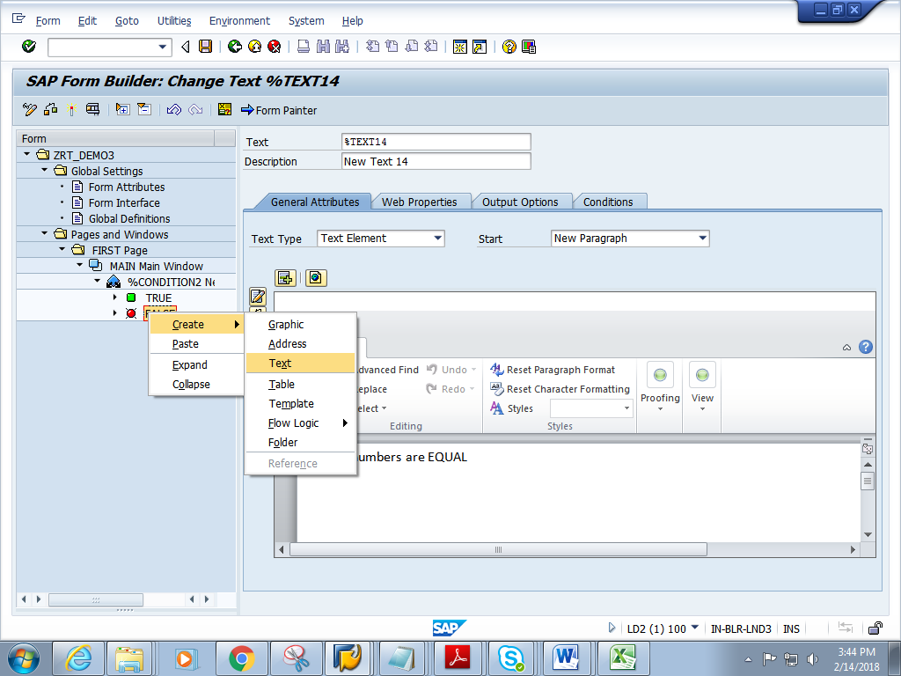

9) Add the below text in TEXT2.

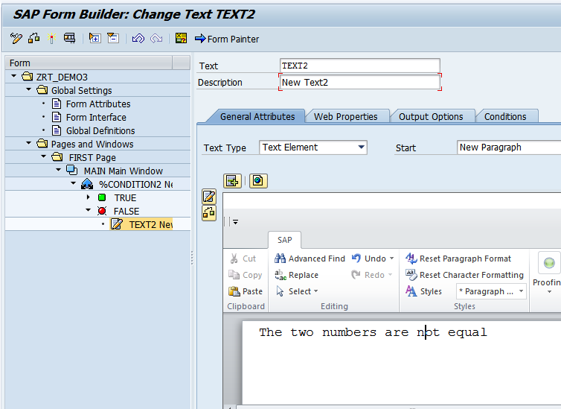

10) Save and activate the form.

11) Execute the form .Execute the function module. **Enter two nos.**

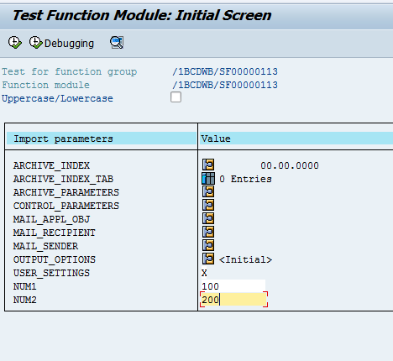

11) Expected output is as follows.

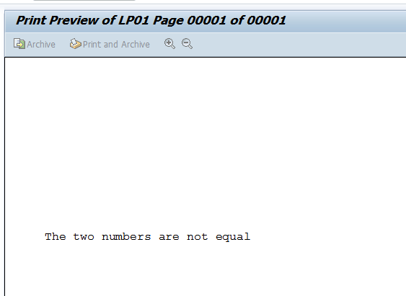

12) Output when equal numbers are given

